Dashboard Setup

**Computer server setup**

* If you are going to be running the server on a windows computer, you will need to make sure you have selected private network for the current wifi network or the robot will be unable to connect 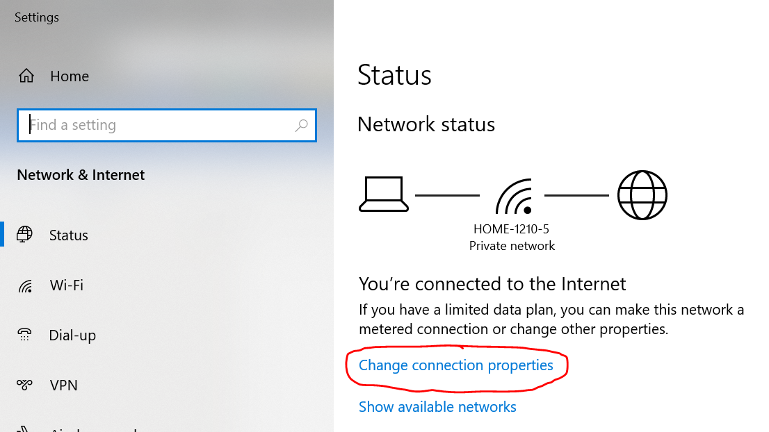 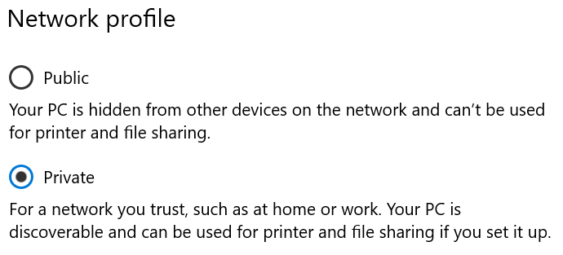
* Open and run the IdeaProjects/2019-framework/utils/src/main/java/dashboard/Dashboard.java class

**Open in web browser**

* Open preferably Chrome, other web browsers may not support full functionality
* If the web browser is open on the same computer as the server, put <http://localhost:5800> into the address bar
* Otherwise put http://[server-computer-ip]:5800 in the address bar. The server computer ip can be found on the java console of the server 

Dashboard Usage

* When robot code starts in sim mode or on the robot, the robot client will automatically connect to the computer server

**Connection Indicator**

* In the upper right corner
  + 4 red bars: server disconnected; robot disconnected 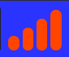
  + 2 green bars, 2 red bars: server connected; robot disconnected 
  + 4 green bars: server connected; robot connected 

**Auto Selector**

* The auto selector is the button in the upper right corner next to the connection indicator
* Pressing the button will open a pop up with drop down menus to select the auto and position
* The possible selections are currently specified in arraylists in the robot WebsocketClient class
* When an auto is selected the relevant details are currently logged to the robot console

**Dev Tab**

* The dev tab contains a table that displays all input and output values
* You can click on the name of a value for a popup which allows you to set the value of inputs, as well as other functions such as graphing and a draggable viewer to make debugging easier
* Just click and drag on a viewer to move it, and double click on one to remove it
* If you double click anywhere on the page it will open the FMS mode and gamepad selection menu, before opening this menu you must press at least on button on each gamepad you want to use
* To use a keyboard as a gamepad, select “1 – Keyboard” in the selector for the gamepad you want the keyboard to emulate
  + 1 = left trigger
  + 2 = left bumper
  + 3 = left joystick
  + 4 = back
  + 5 = dpad
  + 6 = joystick stick button (hold the joystick button (3 or 8) and then click this button)
  + 7 = start
  + 8 = right joystick
  + 9 = right bumper
  + 0 = right trigger
  + a = a
  + b = b
  + x = x
  + y = y
  + Arrow keys = in combo with joystick button (3 or 8) to increment the axes; in combo with dPad button (5)

**Comp Tab**

* This is a tab that is to be used in competition, displaying useful information and possibly a game time display
* Currently this tab has no functionality

**Graph Tab**

* This tab has one large graph on which different datasets can be graphed
* Datasets can be added from the dev tab or the graph method on the dashboard in the framework
* Clicking on a dataset label hides the dataset
* Double clicking on a dataset label removes the dataset
* Double clicking anywhere on the page opens a menu where the graph can be cleared

**Log Tab**

* This tab is a log panel
* Currently all one can do with this tab is call the log method on the dashboard in the framework

**Path Tab**

* This tab is a path generation tool for the pure pursuit system we plan to use for the 2020 season
* Cartesian coordinates can be put in the table on the right side
* The tab will then plot the path defined by the coordinates
* Double clicking anywhere on the page will open a menu where you can copy the path directly into java